Experiment 6: Implement Wi-Fi security (WPA2, IP based, MAC Based)
Aim:
To implement Wi-Fi security (WPA2, IP based, MAC Based)
Procedure:
Step1: Switch On the D-Link Router.
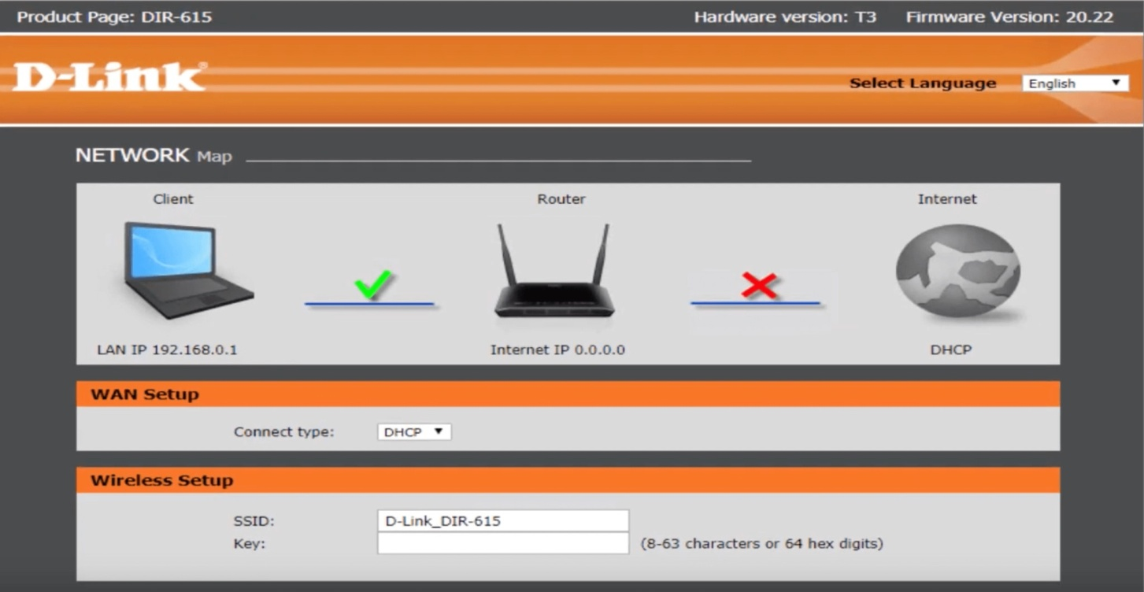
Step2: Open a browser and search for dlinkrouter.local
Login
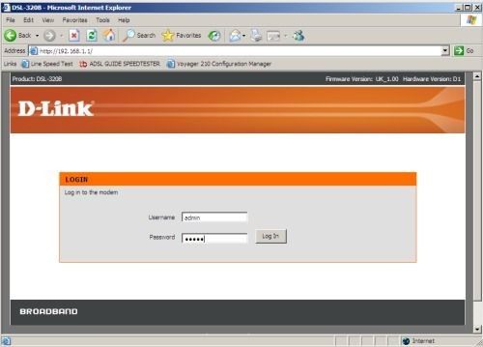

Setup security mode as WPA2

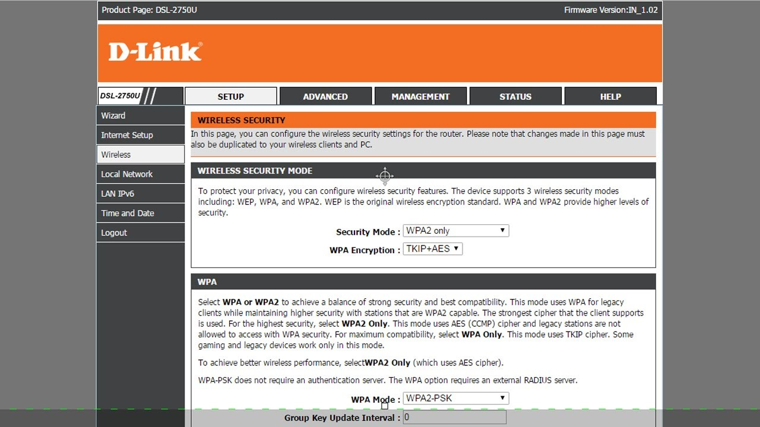
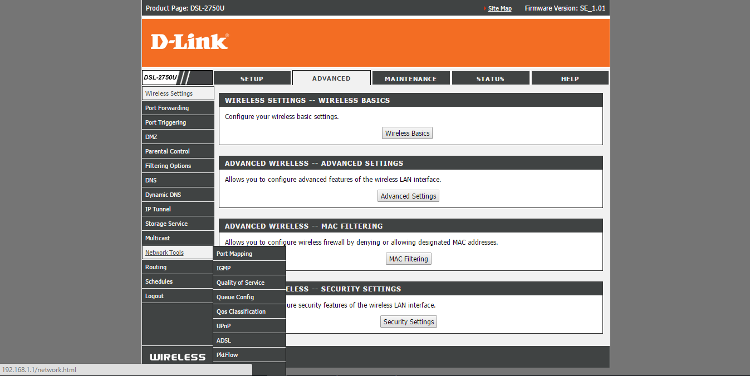
Go to advanced tab

Go to wireless tab

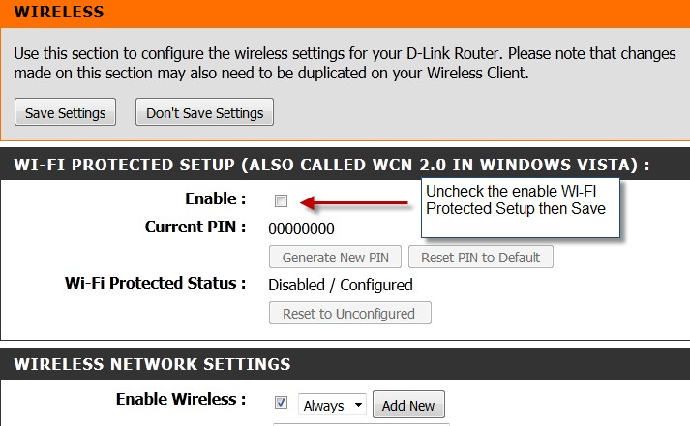
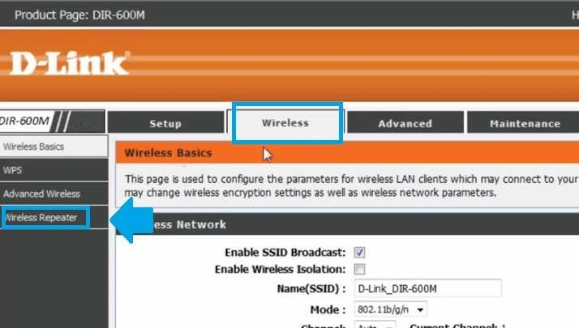
Go to wireless Repeater

Goto status tab

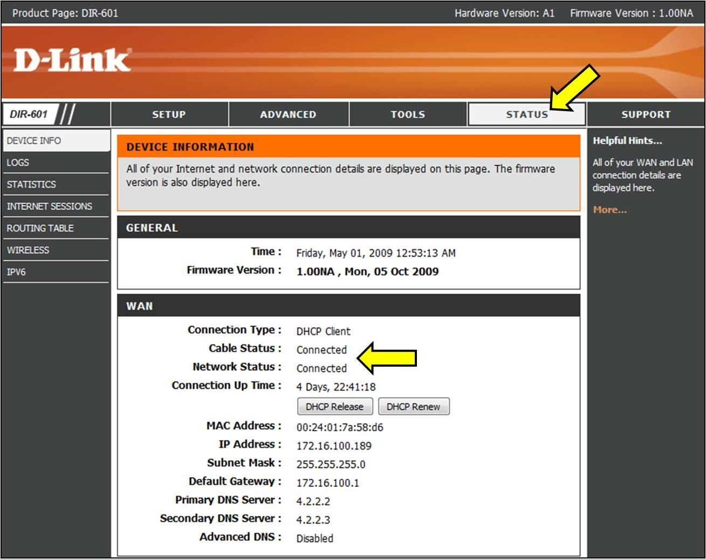

Result:
Thus the implementation of Wi-Fi security was completed successfully.

